DENVER EAGLE P3
COMMUNICATION SYSTEM

OCC~PEI INTERFACE PROPOSAL

CONTRACT NO. | P110701149
CDRL NO. | N/A
WIS DOC. NO. | 42C-2016-0001
REVISION: | 1.1
DESIGNED: | J. S. JEONG
REVIEWED: | J. Y. LEE
APPROVED: | B. J. JONE
DATE: | 1/28/2016



Record of Revisions
Rev. | Date | Description | Entered By
1.1 | 1/28/2016 | Initial release | J. S. Jeong

Table of Contents
1. Introduction 4
2. Background 4
3. General Description on Proposed Solution 5
4. Functions 6
5. Commissioning and Delivery 7
6. Limitations 7

Introduction
This document describes proposed methods to achieve the OCC~PEI communication interface.

Background
An interface concern has been raised during implementing the OCC~PEI call integration, where the on-board communication/intercom system is half duplex supporting and the wayside Avaya phone system is full duplex.
Based on the approved design, Woojin’s on-board intercom system is half-duplex supported analog-voice transmits. All on-board intercom function have standard ‘listen and push to talk design’ by embedded talk button on the handhold set of DPO and DPH which is the same design as SEPTA SVL. All details is presented on the “Table 3-H” and “Table 3-L” of Woojin On-board communication SFD, 423-309, and approved by DTP.
A VoIP module was later incorporated to the design upon the request from the customer for a ‘way to communicate over the WiMax network’. However, there was no given technical requirement describing what exactly needs to be accomplished. Also there were very limited interfacing discussions and/or documentation during the design phase, which is an essential aspect of a project when different parties need to work together.
Despite the difficulties, the following efforts and discussions were made with regards to this interface:
- October 2012
  - Conducted a limited scope of bench test with the Avaya phone at Woojin lab simulator over the VPN remotely
  - The test verified communication between Avaya phone and Woojin VoIP simulator only
  - The test did not verify communication down to DPO and individual PEIs from Avaya phone which should require more crucial interface and details design necessary
- September 2015
  - Woojin has issued how to implement interface issue between on-board half duplex each PEI and OCC Avaya full duplex phone
  - Woojin asked DTP to check technical feasibility for push-to-talk from the OCC which is common design for OCC PEI call in terms of call priorities.
  - DTP said the interface of “OCC to PA/TEXT” with Penta should be the highest priority. So, OCC to PEI interface was not seriously considered
- November – December 2015
  - Woojin noticed that DTP didn’t have a complete understanding on the issue
  - Woojin communicated to DTP again about how it will not work together
  - Now DTP has obtained understanding on the interfacing concern
- Discussed about various options:
  - OCC Avaya phone sending PTT signal over the WiMax – not possible (DTP)
  - Using specific keys like mute switch or number keys – not feasible (Woojin)
  - VOX feature – not feasible (Woojin)
  - Meanwhile Woojin modified an on-board PEI(#4019, F-end) unit incorporating PEI ‘Call’ CPLD logic as push-to talk button – implemented successfully, but needed to be reviewed and approved by DTP.
  - DTP requested to design development of separate “push-to-talk” box installed on OCC to send a PTT command to on-board PEI, must likely CNCS board of CRA during series of recent discussion.

ProposAL for OCC PTT SOULTION
Woojin proposes to deploy an additional PTT switch (or a soft button in a form of software) at the OCC to signal the on-board Comm. to switch between talk/listen modes.
While the on-board VoIP of CRA and Avaya telephone server communicates through regular SIP/RTP, the on-board CNCS of CRA and OCC PTT switch will communicate using customized special protocol to manage the talk/listen modes.
Figure below shows the functional concept of the proposed system.
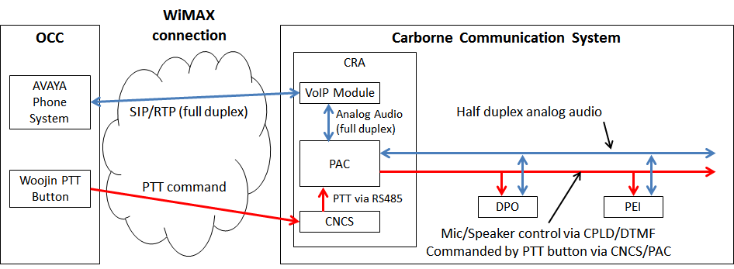

Figure below shows the limitation of the original system where the OCC and the PEI cannot appropriately communicate.
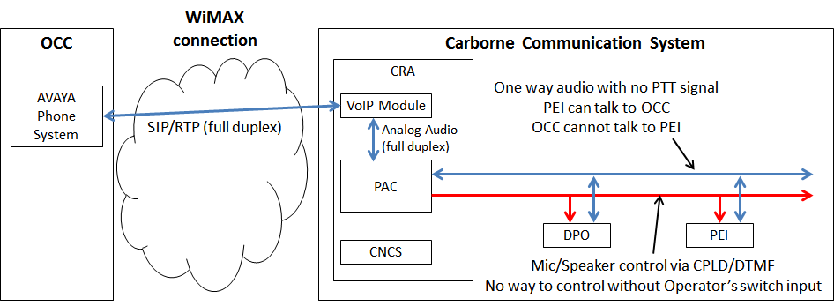

Functions
Below describes how the proposed system will function:
- PEI requests an emergency call
- No response from DPO for 13 seconds. This time is counted by PAC
- If PAC does not acknowledge DPO’s response by 13 seconds, PAC signals VoIP to call the specific phone number, i.e. #2000. PAC uses internal dry contact to signal VoIP
- OCC picks up the call
- Call session between OCC phone and on-board VoIP module is initiated
- CNCS and OCC PTT communicates in a different communication channel using custom protocol
- When OCC PTT is “active”:
  - PTT sends “PTT active” signal to CNCS over WiMax network
  - CNCS acknowledges “PTT active” and transfers the signal to PAC board via RS-485 serial link.
  - PAC acknowledges “PTT active”. Converts to DTMF signal for analog and transfers it to any of activated PEI (or DPO).
: Activate speaker and deactivate microphone on the PEI.
- When OCC PTT is “inactive”:
  - PTT sends “PTT inactive” signal to CNCS over WiMax network
- CNCS acknowledges “PTT inactive” and transfers the signal to PAC board via RS-485 serial link.
  - PAC acknowledges “PTT inactive”. Converts to DTMF signal for analog and transfers it to any of activated PEI (or DPO).
: Deactivate speaker and deactivate microphone on the PEI.
- When call is completed, a contact on the VoIP is opened to close PAC communication.
- PAC clears the call session using DTMF signal (analog)

Commissioning and Delivery
- For on-site commissioning purpose, Woojin and Hyundai-Rotem will perform a demonstration using Windows-based software with PTT function described in this proposal. Woojin targets to complete this activity by 1 week after receipt of DTP’s approval.
- Upon receipt of separate purchase order by DTP, Woojin and Hyundai-Rotem will supply actual PTT switch hardware equipped with the same function.

Limitations
The proposed PTT solution only considers a single call at a time. Advanced telephone-specific features such as multiple calls from different cars, standby calls in queue, etc. are not supported.
Any further expansion to this interface is out of Woojin’s scope of works and technical capability. Woojin will not be able to support any other request from DTP to review potential expansions besides what is proposed in this document.

